- Then select Microsoft in Manufacturer and then select Microsoft Loopback Adapter (For Windows 10: Microsoft KM-TEST Loopback Adapter) in the Model and then click next and Finish. (Add Screenshot)
- 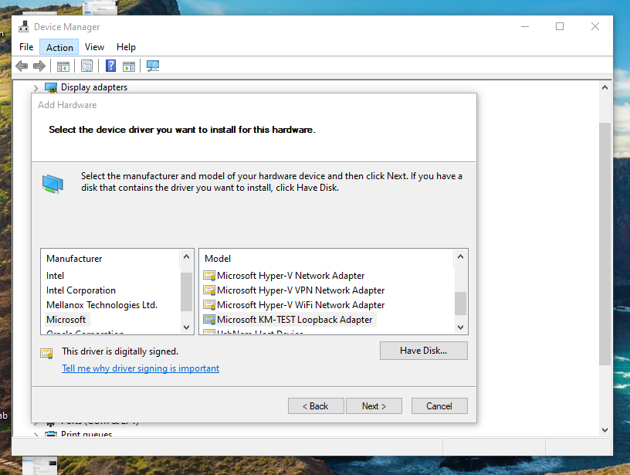

- You should see a new MS Loopback Network Adapter which we just created. (Add Screenshot)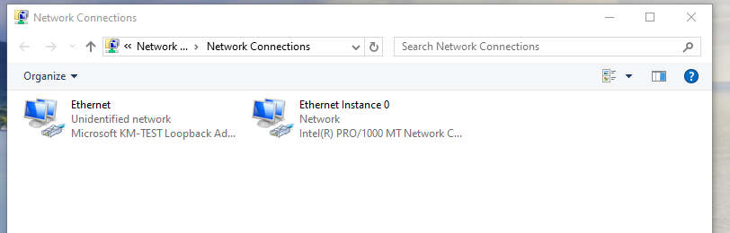

- Right click on Host Network Adapter and click on Properties.
Click on Sharing, Check the option “Allow other network users to connect through this computer’s Internet connection” and select the Loopback Network Adapter which we created earlier. Also, check on “Allow other network users to control or disable the shared Internet connection” option and click OK.
Note: This process is to allow Internet Connectivity through Loopback Network Adapter. (Add Screenshot)
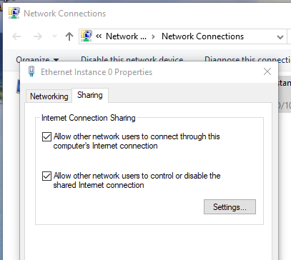
- For the DNS server select Use the following the DNS server address option and keep the Preferred DNS server and Alternate DNS Server address blank. When done click OK. (Add Screenshot)
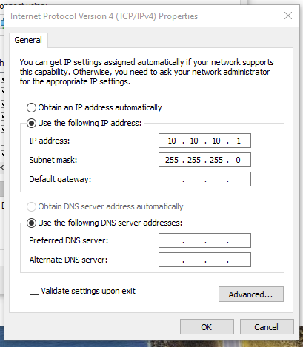
- Open Command Prompt, run “ipconfig” command. Your Loopback Adapter details should look similar to as below. (Add Screenshot).

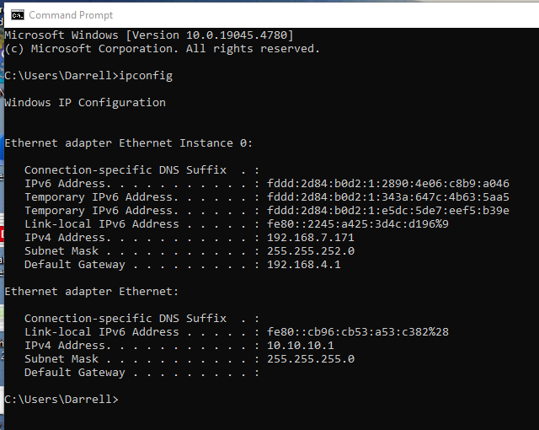

LAB 2 Part 2:
- Download and Install VirtualBox for your respective Windows or Mac OS machine. (Add Screenshot)

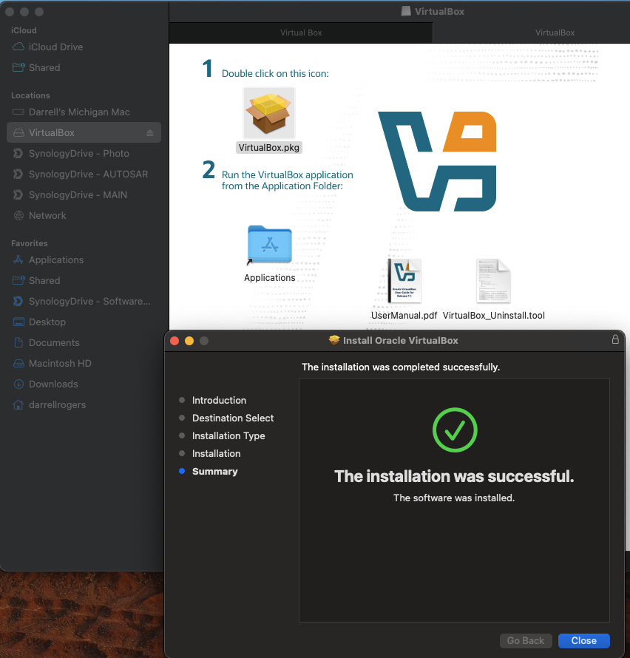

LAB 2 Part 3: Deploy CentOS VM:
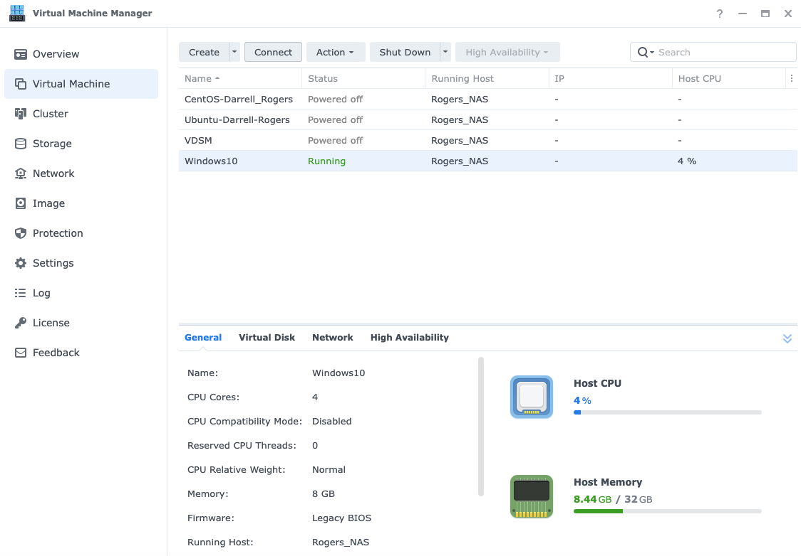

LAB 2 : Your CentOS VM is almost ready:
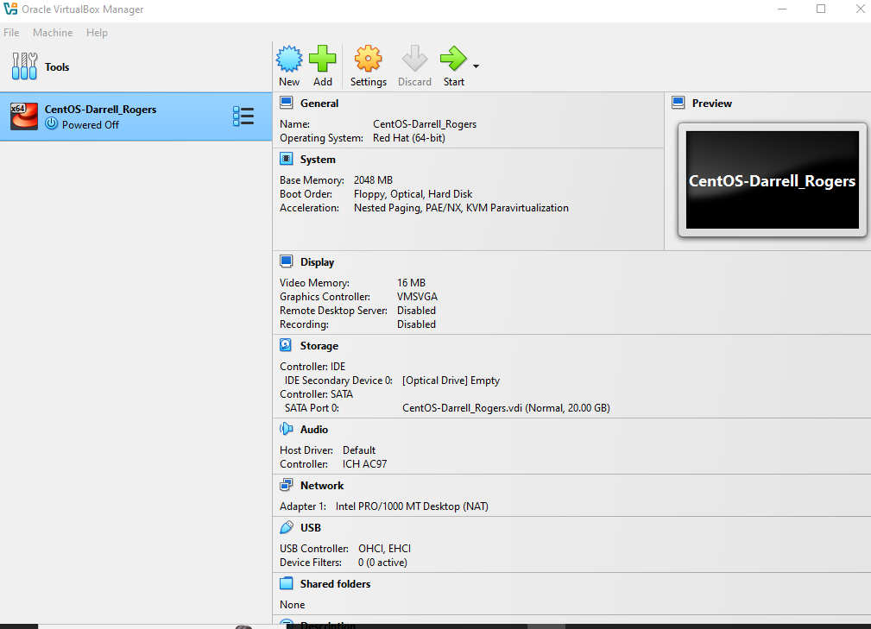

Before powering ON the VM, select the VM and click on Settings which is at the left top and go Network Section and Select Attached to: Bridge Adapter and Name: Microsoft Loopback Adapter (Which we created in Step 1). This way we are bridging the VM Network with the Host Network. (Attach Screenshot)
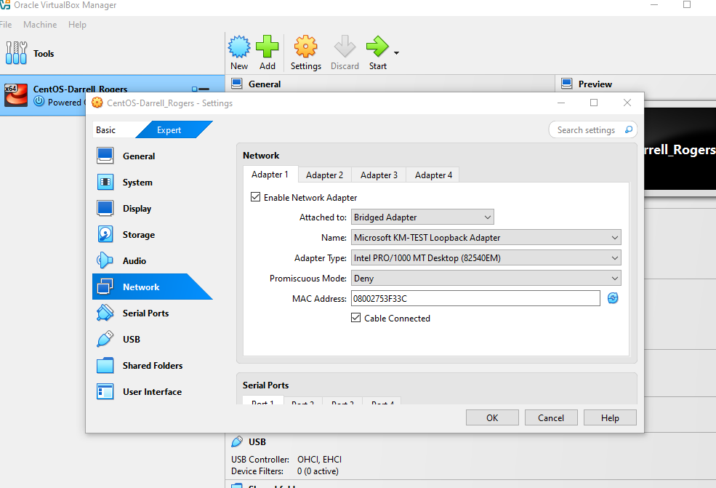

Once that is done, go to storage section and select Controller: IDE > Empty and click on the rightmost disk option and browse the ISO file that you downloaded earlier here. (Attach Screenshot)
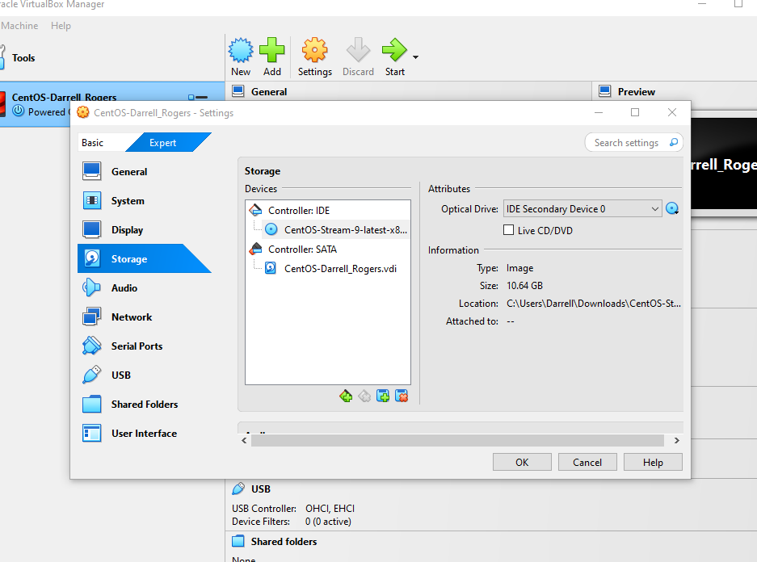

After reboot, Login into the system with your credentials (FirstnameLastname). (Attach Screenshot) 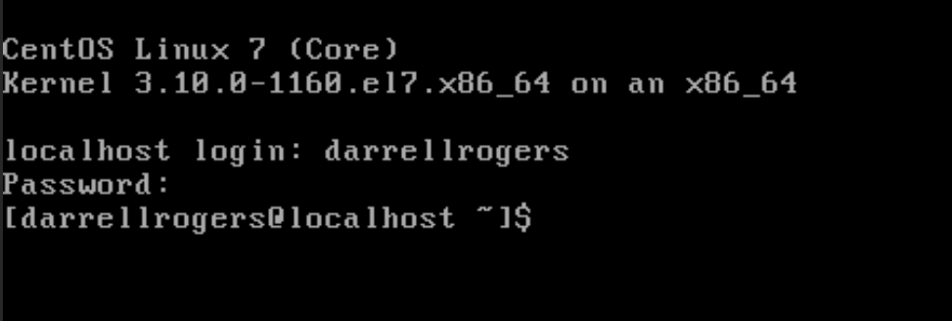

LAB 2 Part 4 : Configure VM:
Type in the command “ip a” to get the VM Network Adapter details. Note down the MAC Address for future use. MAC Address: 08:00:27:5c:5d:eb (Yours will be different!) (Attach Screenshot)
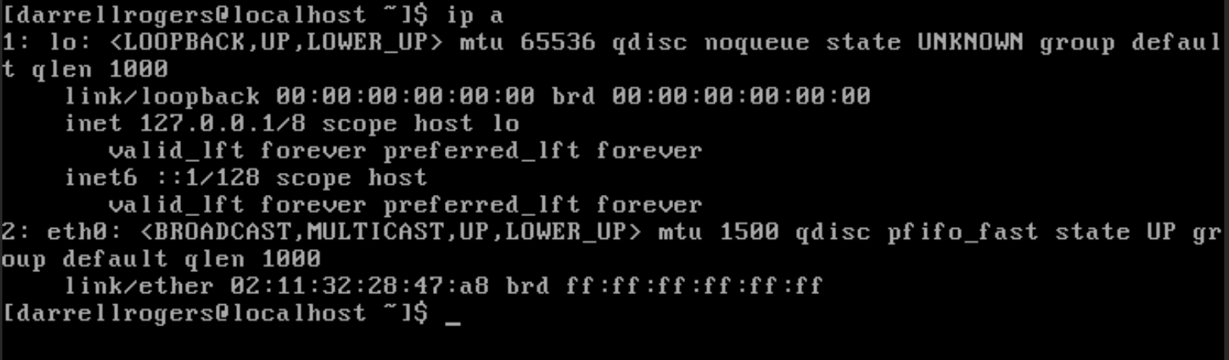
Let’s now set the permanent static IP Address on the VM.
Run the below command and locate the VM Network Adapter configuration file. (Attach Screenshot)
Command: cd /etc/sysconfig/network-scripts
Filename: ifcfg-enp0s3
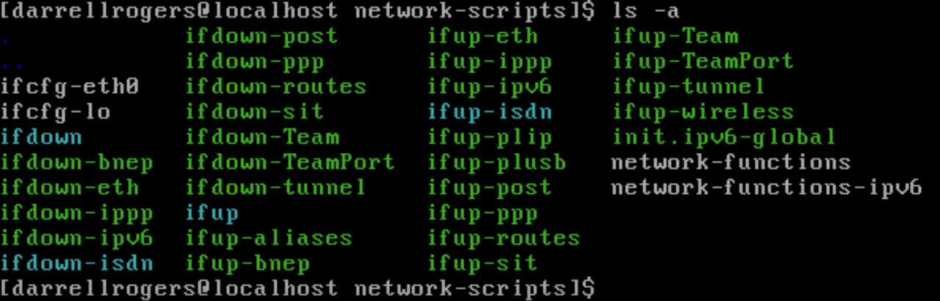

Run the below command to delete this configuration file. (Attach Screenshot)
Command: sudo rm -f ifcfg-enp0s3
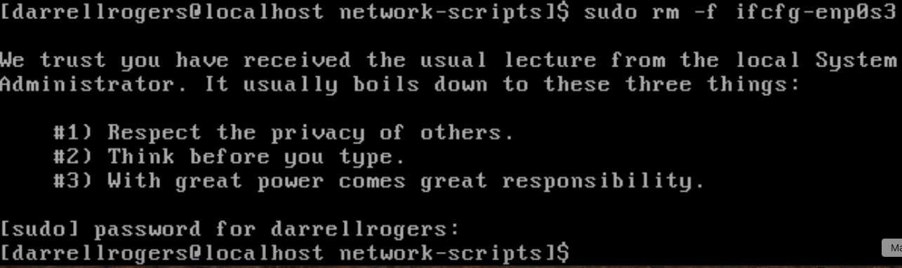
Run the below command to create a new Network configurations file of the same name. (Attach Screenshot)
Command: sudo vi ifcfg-enp0s3
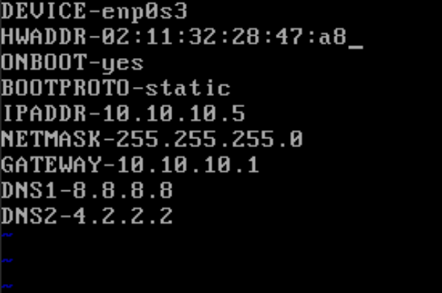

Run the below command to restart the Network Manager service. (Attach Screenshot)
Run the below commands to enable/disable the VM Network Card. (Attach Screenshot)
Command: sudo ifdown enp0s3
Command: sudo ifup enp0s3
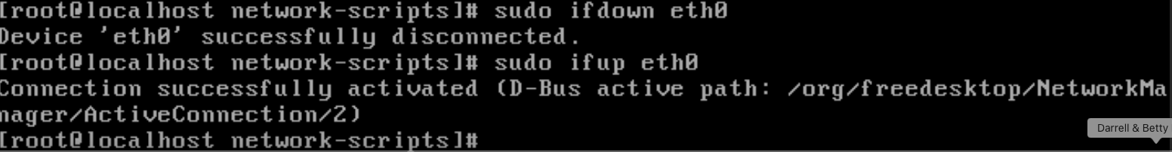
Run the below command to check whether the IP has been assigned to the system or now? (Attach Screenshot)
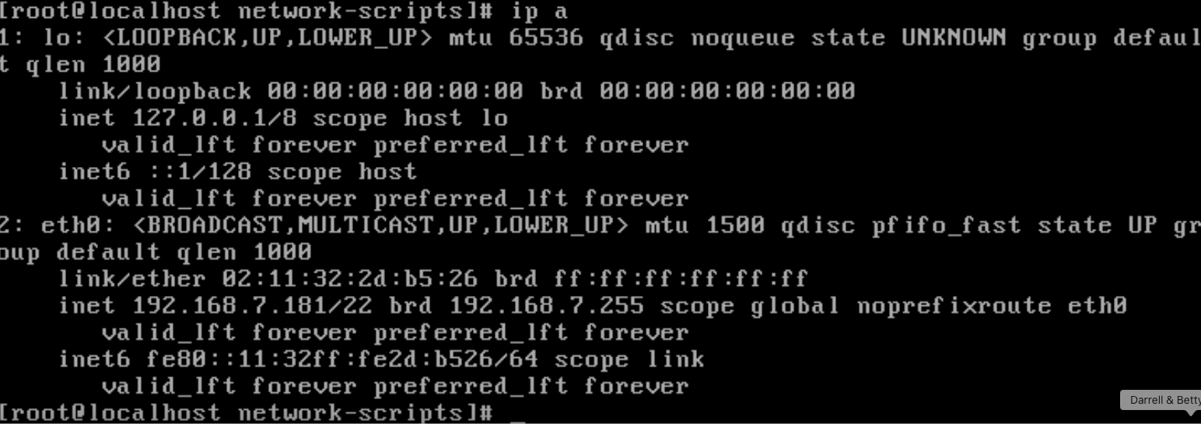
Run the below command to verify the DNS entries have been updated in the System. (Attach Screenshot)
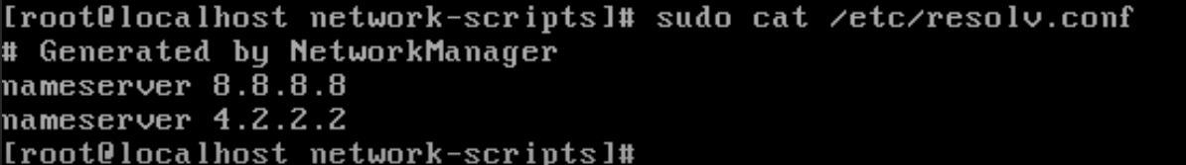
Run the below command to check the Internet Connectivity on the CentOS System. (Attach Screenshot)
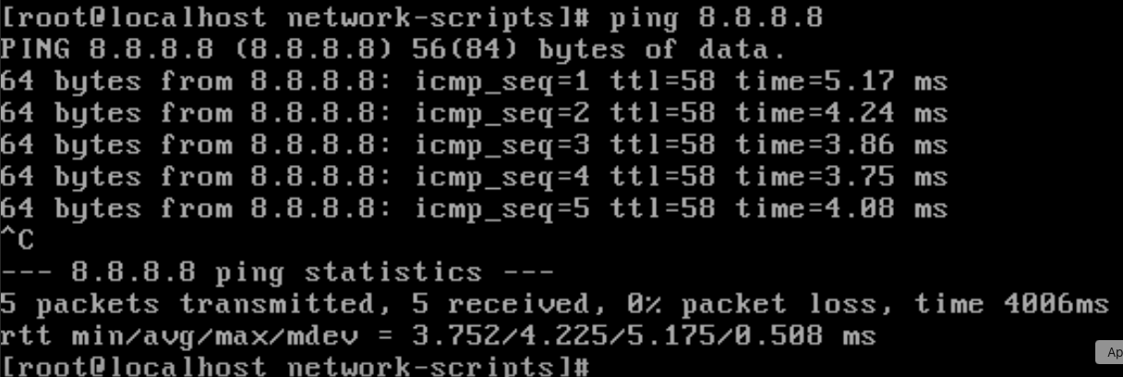
Also ping the Host System from the CentOS VM.
Command: ping 192.168.4.1 (MY BARE METAL HOST)
Come to your Host Machine (Windows) and open the Command Prompt.
Run the below command to check the connectivity with the CentOS VM. (Attach Screenshot)
Command: ping 10.10.10.5 (You should get ICMP replies back.)
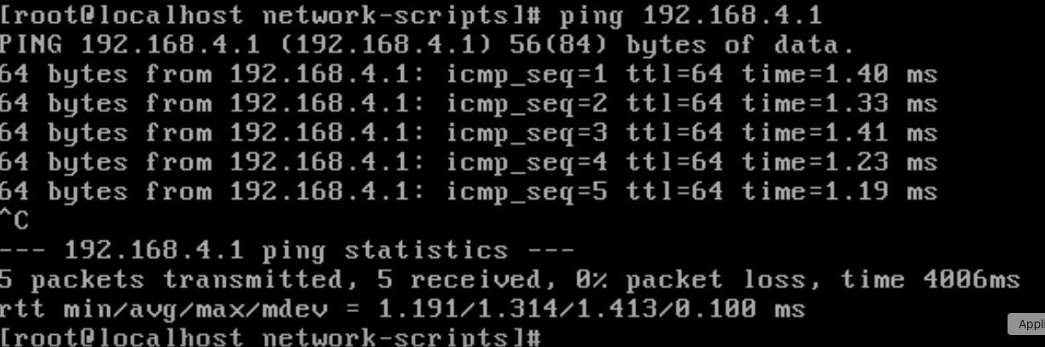

Step 5: Boot CentOS 7 in GUI Mode (Desktop Environment)
Come back to the CentOS terminal on VirtualBox.
To update the packages in the system, run the below command.
Command: sudo yum update -y

Let’s install GNOME Desktop with the following command. (Attach Screenshot)
Command: sudo yum groups install "GNOME Desktop"

Once it’s completed, run “startx” command.
Command: startx
You’ll observe that the CentOS7 system is now available in GUI mode.

You need to go through accepting a license, configuring language, keyboard type, etc. and finally you will have the CentOS GUI ready. (Attach Screenshot)

Open terminal within the VirtualBox and run the below commands to set GUI mode permanently.

Command: sudo systemctl set-default graphical.target (Attach Screenshot)

Reboot the CentOS System using below command.
Command: reboot

You’ll now boot up in GUI mode permanently.

Login into the CentOS system with your credentials. (Attach Screenshot)

Open the web-browser (Mozilla) and check the Internet Connectivity. (Attach Screenshot)

Open the terminal again and run the below commands to install vim and emac2 software in the CentOS system.
Command: sudo yum install vim -y (Attach Screenshot)

Command: sudo yum install emacs -y (Attach Screenshot)

---END OF LAB----

